PYTHON LAB COMPONENTS
NAME: Ninada S.A
USN: 1RUA25BCA0075
PYTHON LAB COMPONENTS

Table of Contents:

1. Basic Programming and Syntax
- Program 1.1: Implementation of a Simple Arithmetic Calculator
- Program 1.2: Temperature Conversion (Celsius and Fahrenheit)
- Program 1.3: Identification of the Largest of Three Numbers

2. Functions and Recursion
- Program 2.1: Calculating Factorial Using Recursive Functions
- Program 2.2: String Analysis: Word Count and Processing

3. Data Structures
- Program 3.1: List Manipulation: Insertion, Deletion, and Searching
- Program 3.2: Dictionary Merging and Key-Value Pair Operations

4. File Handling & System Operations
- Program 4.1: CSV File Reading and Basic Data Analysis
- Program 4.2: File System Awareness: Renaming, Moving, and Accessing Folders

5. Numerical Computing with NumPy
- Program 5.1: Creating and Reshaping NumPy Arrays
- Program 5.2: Matrix Mathematics: Addition and Dot Product Operations

6. Data Manipulation with Pandas
- Program 6.1: DataFrame Construction from Scratch and CSV Sources
- Program 6.2: Data Cleaning: Handling Missing Values and Duplicates

7. Statistical Analysis
- Program 7.1: Descriptive Statistics: Measures of Central Tendency and Dispersion
- Program 7.2: Data Distribution Analysis: Skewness, Kurtosis, and Quantiles

8. Feature Engineering & Preprocessing
- Program 8.1: Categorical Encoding: LabelEncoder and OneHotEncoder
- Program 8.2: Data Scaling: StandardScaler and MinMaxScaler Implementations

9. Outlier Analysis
- Program 9.1: Visualizing Outliers via Box Plots (Matplotlib/Seaborn)
- Program 9.2: Outlier Detection using Interquartile Range (IQR) Method

10. Advanced Data Operations
- Program 10.1: Advanced Pandas: GroupBy, Merging, and Concatenation
- Program 10.2: Case Study: Time Series Analysis of Data

11. Advanced Visualization and Correlation
- Program 11.1: Visualizing Data Distributions and Pair Plots
- Program 11.2: Correlation Matrix Mapping using Heatmaps
- Program 11.3: Identifying Trends and Relationships via Line and Scatter Plots
- Program 11.4: Analyzing Categorical vs. Numerical Relationships with Bar Plots

Basic Programming and Syntax
1.Basic Programming and Syntax:

A. Simple Calculator-
Code-
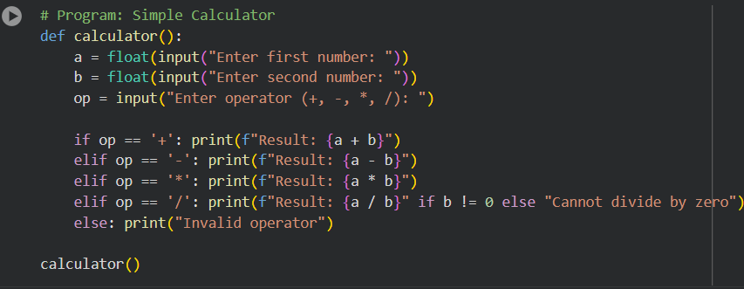
Output-
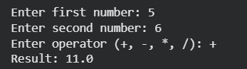

B. Temperature Converter-

Code-
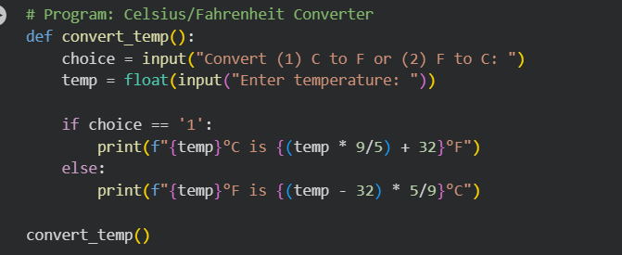
Output-
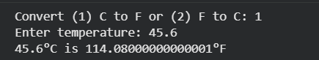

C. Largest of Three Numbers-
Code-
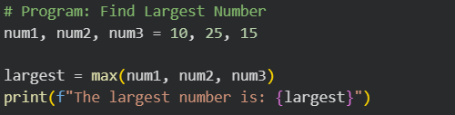
Output-


Functions and Recursion
2.Functions and Recursion:

A. Factorial using Recursion-

Code and Output-
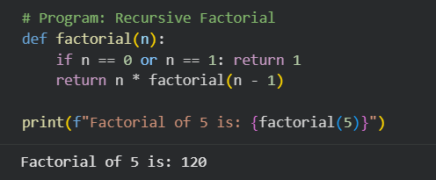

B. Word Count Program-
Code and Output-
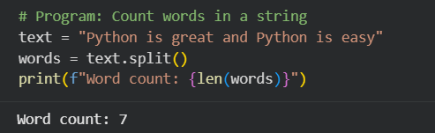

Data Structures
3.Data Structures:

A. List Operations-

Code and output-
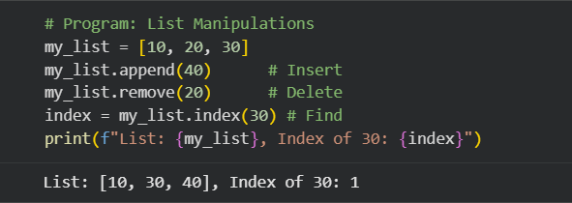

B. Merge Two Dictionaries-

Code and output-
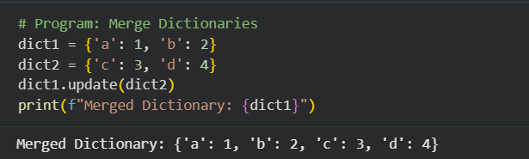

File Handling & CSV Analysis
4.File Handling & CSV Analysis:

A. CSV Analysis and File Management-

Code and Output-
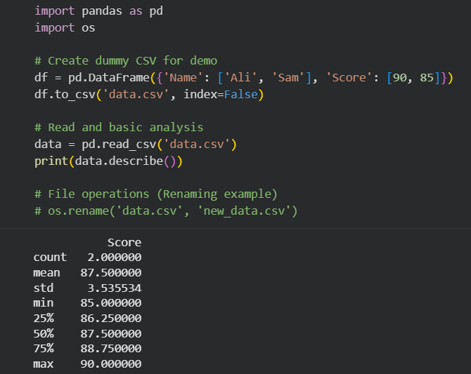

NumPy Basics
5.NumPy Basics:

A. Creating and Manipulating Arrays-

Code and output-
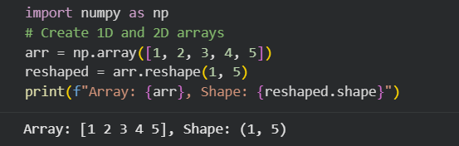

B. Matrix Operations-

Code and output-
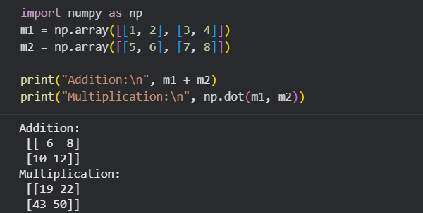

Pandas Basics
6.Pandas Basics:

A. DataFrame from Scratch-

Code and output-
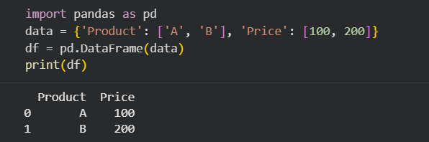

B. Data Cleaning

Code and output-
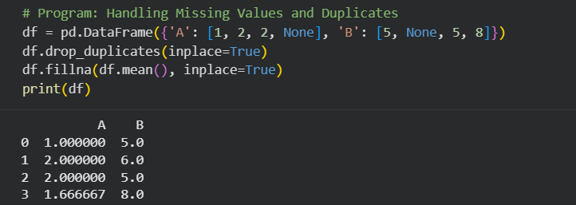

Descriptive Statistics
7.Descriptive Statistics:

Code and output-
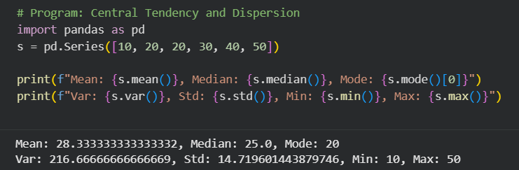

Data Distribution
8.Data Distribution:

Code and output-
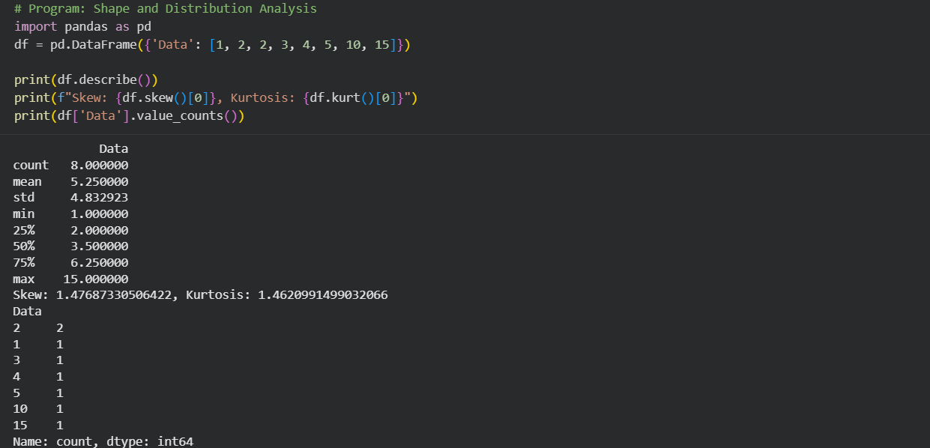

Categorical Encoding
9.Categorical Encoding:

Code and Output-
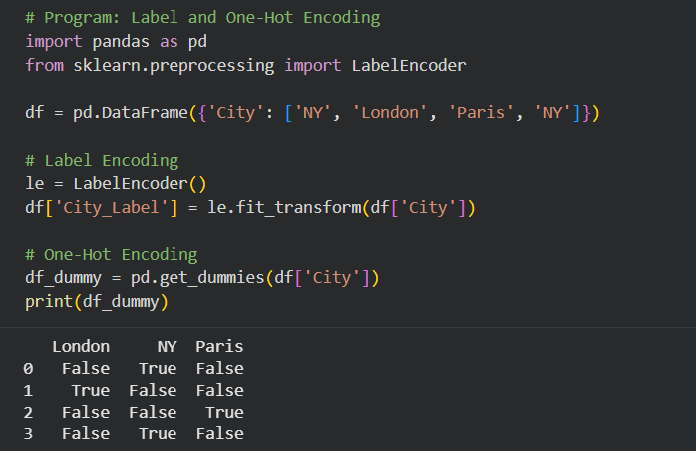

Data Scaling
10.Data Scaling:

Code and output-
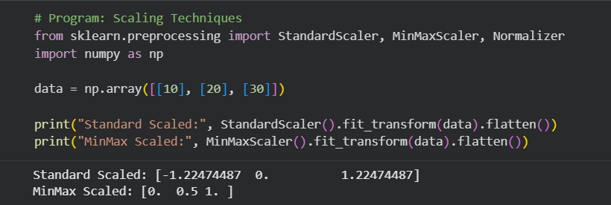

Outlier Detection
11.Outlier Detection:

A & B. Boxplot and IQR Method-

Code and output-
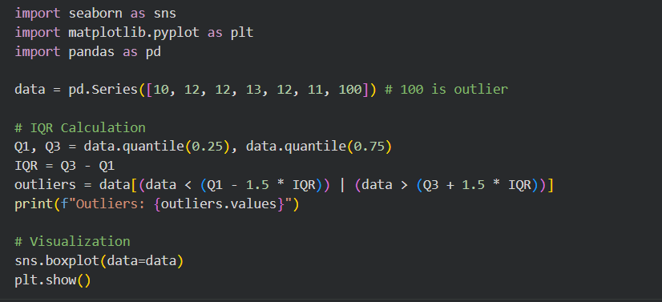
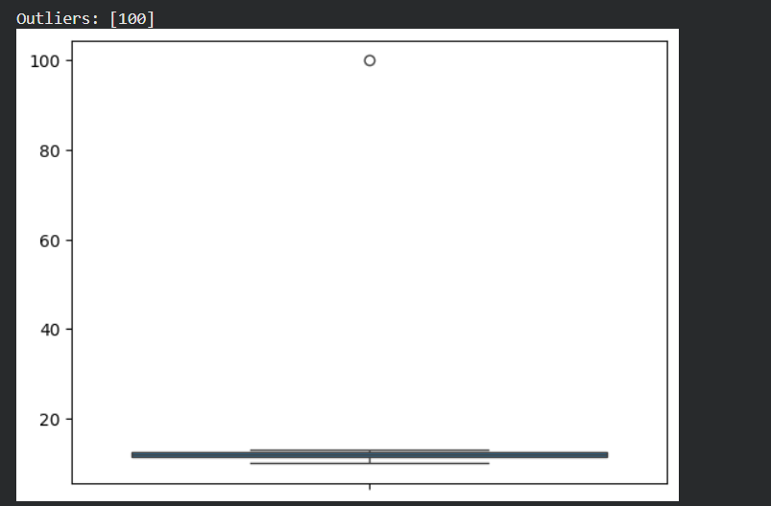

Advanced Pandas
12.Advanced Pandas:

A. GroupBy, Merge, Join:

Code and output-
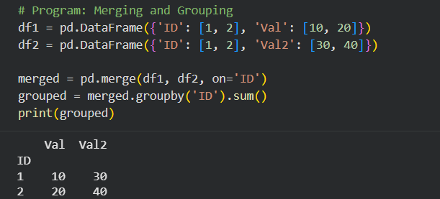

Advanced Visualization & Relationships:
14-17. Advanced Visualization & Relationships:

Code-
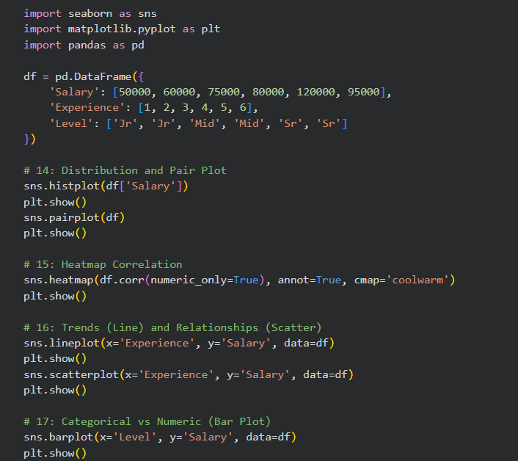

Output-
